|  |
| --- |
| ​​BRIGHAM YOUNG UNIVERSITY - IDAHO​  ECEN 299 – Lab 4​ |
| ​​Mixer and Microphone Preamp - Part 1 Schematic and Simulation, Part 2 Layout​ |
|  |
|  |
| **​​5/9/2024​** |

# Objectives

Design the microphone pre-amp and mixer portion of your dual-channel stereo system, with special emphasis on the PCB. When this lab is complete, you will have a PCB layout prepared to be fabricated. In Lab 8, you will assemble the PCB and evaluate the performance of your design.

# Background

This stereo system will have a microphone input, but this creates 2 issues: the input signal from the microphone is very small and must be amplified, and the microphone output is only a single channel. The pre-amp will solve the first problem, and two mixers will add the single-channel signal to both the left and right channels. With the volume control module situated before the mixer stage, the microphone and audio signals will have separate and independent volume controls.

# Procedures

## To Create a New Project in BYUI Workspace

1. Start Altium Designer.
2. Sign In and get a license.
3. Select BYUI as your active server.

1. Select Panels > Projects.
2. Right click Project Group 1.DsnWrk.
3. Select Add New Project.
4. Select the following:
   1. Locations: BYUI.
   2. Project Type PCB > <Empty>.
   3. Project Name: Lab4_PAM
5. Expand Advanced.
6. Select the Folder ellipsis (…).
7. Select your class work folder. It has the form Lxx <lab partner1> & <lab partner 2>.

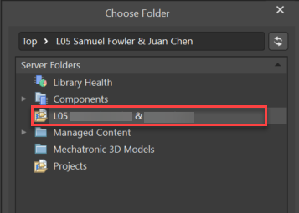

1. Select the Local Storage ellipsis.
2. Browse to %UserProfile%\Desktop\ECEn299

1. Select Create.

## Add Schematic Sheet

1. Right click on **Lab4_PAM.PrjPcb**.
2. Select **Add New to Project > Schematic** document. *(If SCH list shows up you can drag it to the side of the screen or park it to the side of the main window.)*
3. Right click on **Sheet1.SchDoc**.
4. Select **Save**.

The default directory is the project directory: Desktop\ECEN299\ Lab4_PAM.

1. Enter File name: **Lab4_Sheet1.SchDoc**.
2. Select **Save**.

## Add a PCB Layout Document

1. Right click on **Lab4_PAM.PrjPcb**.
2. Select **Add New to Project > PCB.**

PCB1.PcbDoc is created.

1. Right click on **PCB1.PcbDoc**.
2. Select **Save**.

The default directory is the project directory: Desktop\ECEN299\ Lab4_PAM.

1. Enter File name: **Lab4_PCB1.PcbDoc**.
2. Select **Save**.

## Create a Symbol for the 10 Pin Header

1. Select Panels > Project (if not already open).
2. Right click Project Group 1.DsnWrk.
3. Select Add Existing Project.
4. Browse to C:\Users\<…>\Desktop\ECEN299\ECEN299_Library
5. Select ECEN299_Library.LibPkg.
6. Select Open.
7. Double click on ECEN_Library.SchLib.
8. Select Panels > SCH Library.
9. Select Add.

1. Type ‘**10 Pin Header**’ for the Design Item ID.
2. Click OK.
3. Select 10 Pin Header Pin.
4. Select Tools > Symbol Wizard.
5. Enter **10** for the Number of Pins.
6. Select ‘**Single in-line**’ as the Layout Style.
7. Enter the **pin names** in the Display Name column and select the **Electrical type** as per the figure below.

1. Select Place > Place Symbol.
2. In the Properties window, under Parameters, ensure that 'Footprints' is selected (highlighted in blue), then click on Add... > Footprint.

1. Click on Browse and select **KBS_10pin_Header_PreA_Mixer**.A screenshot of a computer

   Description automatically generated
2. Select OK.
3. Select Pin Map and verify accuracy.

1. Select OK to close Model Map
2. Select OK to close PCB Model.
3. In the Properties window, under Parameters, click on **Add... > Simulation**.
4. Select 'Browse' and locate your **DONOTHINGSPICEMODEL.CIR** file, which was created in Lab 2 (refer to Lab 2 if needed). Then select Open and OK.
5. In the Projects Window, right click **ECEN299_Library.SchLib** and select Save.
6. Right click **ECEN299_Library.LibPkg** and select Compile Integrated Library…
7. Save your Project.
8. In panels navigate to SCH Library. You should now see the 10 Pin Header included among the other Design Item ID’s shown here.

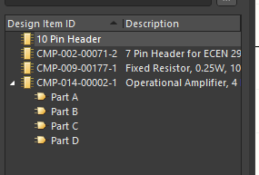

## Designing the Microphone Pre-Amp and Mixer

Ensure everything is saved up to this point and double click on the Lab4_Sheet1.SchDoc to start placing components.

Using lab 2 instructions, create the circuit with the appropriate values for resistors and op amp designators as shown in this picture.

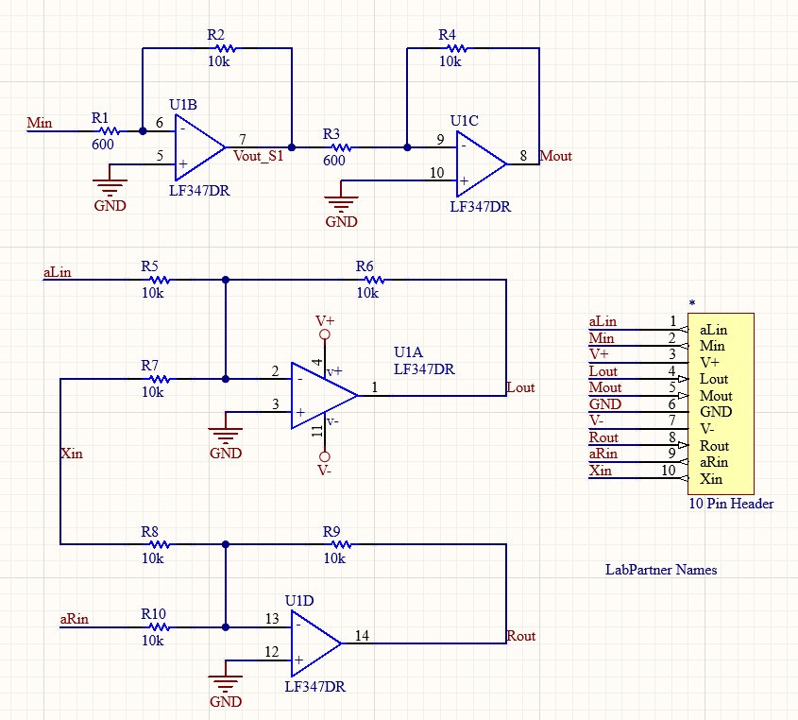

After this lab you will need a screenshot of your working schematic along with your name. You will not need to turn in this screen shot until the Lab 8 lab report.

## PCB Tester Compatibility

Verify that your design is compatible with the PCB Tester that was created at BYU-Idaho that can check for shorts and opens in your PCB after it is fabricated. To be compatible with the tester, assign the op amps in you circuit using the instructions in Fig. 8

*Figure 8 Taken from the document titled “Op Amp Selection for PCB Tester Compatibility.docx”*

## Simulate the Pre-Amp

1. Applying simulation insights gained from lab 2, create two DC sources into your schematic: one set at **+14 volts** and the other at **-14 volts** to supply power to the Op-Amp.

1. Add a Sinusoidal source to Min with an amplitude of **40 mV** and a frequency of **1k Hz**.

1. Create a Transient Analysis for each amplifier stage (Stage, as well as the overall gain. To calculate the gain of a cascade configuration (overall gain) can be found by applying the following equation:

**Note: When creating the transient output expressions, make sure to simulate each state separately. (I.e., first stage would include Min, and Vout_s1 on different channels as shown here.)** A screenshot of a computer

1. To add a measurement cursor to, and take measurements from, a single waveform in the Waveform Analysis window, click on the waveform name (i.e., v(Mout)).
2. The selected waveform will become bolder in color and have a dot to the left of its name.
3. Navigate to **Wave > Cursor A or Cursor B** in the main menus, or right-click on a waveform’s name and select **Cursor A or Cursor B** from the options.
4. Determine the waveform’s amplitude by positioning the cursor at its peak.
5. Measurement data can be found in the **Measurement Cursors** section of the Slim Data panel. For further information on cursors, consult the following material: <https://www.altium.com/documentation/altium-designer/simulation-results#cursor-based-measurements>
6. The figure below shows the transient analysis of the overall gain of the Pre-amp.

1. The values for and will be obtained during Lab 8

*Table 2 Calculated, Simulated, and Actual Results for Each Amplifier Stage*

|  |  |  |  |  |  |
| --- | --- | --- | --- | --- | --- |
| **Description** | **Vin** | **Vout(calculated)** | **Vout(simulated)** | **Vout(actual)** | **Av(actual)** |
| Pre-Amp, Stage 1 | 40mV | 666mV | 661mV | mV | mV |
| Pre-Amp, Stage 2 | 666mV | 11.1mV | 11.1mV | mV | mV |
| Pre-Amp, Total | 40mV | 11.1mV | 11.1mV | mV | mV |

   For the gain calculation, Av(actual), use the Vin and Vout(actual)

## Simulate the Mixer

1. Add Sinusoidal sources to aLin, and aRin, setting their amplitude to 1 V and frequency to 1k Hz.
2. Add a Sinusoidal source to Xin and set its amplitude to 1V and frequency to 100 Hz.
3. In the Simulation Dashboard, remove output expressions from the Pre-Amp Simulation.
4. Create a Transient Analysis for the Mixer, adding the Output Expressions **aLin** and **Xin** in **plot 1**, and **Lout** in **plot 2**.
5. Run the Transient Simulation. Your result for one channel should look like Figure below, where both input signals are identifiable from the summed signal A screenshot of a computer screen

   Description automatically generated

Include simulation screenshots in your lab report which verifies that both mixers work as expected.

# Lab 4 (part 2 of 2)z

## Choosing the right footprint to the resistors

By default, the resistors are assigned the **KBS_SMD0603 footprint**. As a reminder from Lab2, we designated the resistors RinLeft, RfLeft, RinRight, and RfRight as R1, R2, R3, and R4, respectively, and configured their values to {R1=10k, R2=30k, R3=10k, R4=30k}. However, please note that the sizes of the resistors may vary from the default 0603 size. To ensure your resistors have the correct footprint sizes, check the component list provided in your lab kits.

In each kit, you'll find two paper sheets, one for you and one for your lab partner. These sheets contain all the components necessary for creating daughter boards throughout the semester. It's important to note that resistor sizes may vary across kits (e.g., kit 1, kit 2, etc.). Your paper sheet will highlight the specific size corresponding to the footprint size of your resistors. **For instance:**

|  |  |  |
| --- | --- | --- |
| **Resistor Unique Value** | **PCB Footprint Size (Highlighted is the size)** | **Cell (Footprint to use in Altium)** |
| 600 Ω | 0603  0805  1206 | KBS_SMD0603  KBS_SMD0805  KBS_SMD1206 |
| 820 Ω | 0603  0805  1206 | KBS_SMD0603  KBS_SMD0805  KBS_SMD1206 |
| 4.0K Ω | 0603  0805  1206 | KBS_SMD0603  KBS_SMD0805  KBS_SMD1206 |
| 10K Ω | 0603  0805  1206 | KBS_SMD0603  KBS_SMD0805  KBS_SMD1206 |
| 30K Ω | 0603  0805  1206 | KBS_SMD0603  KBS_SMD0805  KBS_SMD1206 |
| **All value CAPACITORS** | **0805** | **My_SMD0805** |

1. To assign a different footprint size to your resistor, navigate to your Schematic Sheet, double-click on the resistor, and the Properties window will open.
2. In the Parameters section, select the drop-down menu located under the Value column next to the Footprint.

1. Select the footprint size according to your component sheet.

## Transfer Schematic to PCB

1. Validate your PCB Project as learned in the *Validating in Altium Designer* section of *Lab 3*.
2. After running the validation, view the Messages panel to check the report. Address any errors and ensure that your project is error-free before transferring it to the PCB.

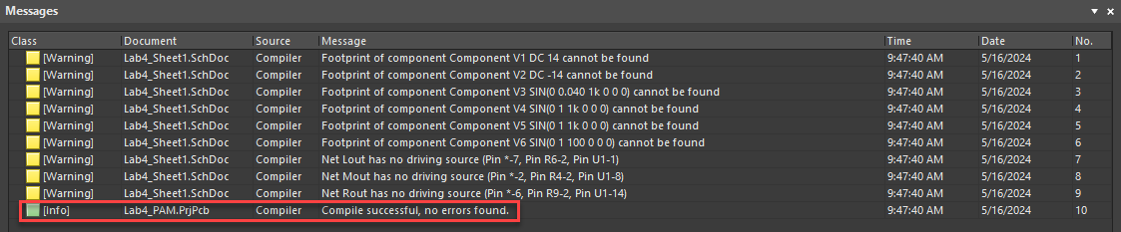

1. Transfer your schematic to the PCB by selecting **Design > Update PCB Document**. For further assistance, please refer to *Transfer Schematic to PCB* section in Lab 3.

# Shaping the Board Outline

## Board Outline for Mixer Maximum Dimensions

The figure below shows the **maximum** **dimensions** for the board outline for the Mixer PCB to fit into the chassis. The figure is not to scale. **Smaller is typically better** for ease of inserting the header pins, but the maximum values should not be exceeded.

You will be graded on the thoroughness of your lab write-up and the quality of your board. If you submit your board with errors, you will be asked to quickly correct them and resubmit the Gerber zip file to be ready in time to be included for fabrication.

1. Define the board size by placing a rectangle not exceeding the maximum dimensions of **X: 1600 mil** and **Y: 1400 mil**.
2. Make Mechanical 1 as the active layer.
3. Select Place > Rectangle.
4. Make sure that the lower left corner of your rectangle starts at the origin.

# Constraints and Clearances (PCB Design Rules)

It is important to make sure the boards we create in this class fit the constraint needs of the PCB fabrication company JLCPCB. These important constraints include trace width, via sizes, and clearance between conductors. To set these important constraints use the following steps.

1. Go to design > constraint manager.
2. In the Properties Pannel, look under General and make sure the Units are set to mils.

1. In the Clearances tab, verify that *All Net Classes* are set to **10mil** as shown in the image below. If you need to modify this value, you can do so at the bottom left of the screen. A screenshot of a computer

   Description automatically generated
2. Click on the tab labeled Physical and check the following constraints for “All Nets".

* 1. Ensure Min Width, Preferred Width, Preferred Diff Pair Gap, and Clearance is set to 10mil.
  2. Check to make sure Via Style is set to 24mil, 12 mil (for diameter and hole size).
  3. Check to make sure Polygon Connect is set to Relief connect, 10mil, 10mil, 4, 90.
  4. To edit these constraints, click on the current value and then go to the corresponding diagram that shows up near the bottom left of the page.

1. Edit the default via properties by selecting the gear icon at the top right of the screen. 
2. Navigate to **PCB Editor > Defaults > Via.**
3. Choose **Simple** under Via Stack.
4. Select **Manual** for Solder Mask Expansion.
5. Choose **Type1b – Tenting** for the IPC 4761 Via Type under the Via Types & Features section.

1. Select Apply and OK.
2. After ensuring the correct constraints, a new file called Lab4_PCB1.PcbDoc [Constraints] will be created. Go to view>panels>projects and save any files that need saving up to this point.

# Placement and Routing

1. Understanding the configuration of the LF347DT IC and your schematic will help in placing your components on the board.

1. After placing the components, make sure the 10-pin header is within the limits as shown in the *Board Outline for Mixer Maximum Dimensions*section of this lab.
2. To measure and display the distance between two points, press **Ctrl+M**.

**Note:** Making the grid size smaller (i.e., 1 mil) will increase the precision of your measurements.

1. Position the cursor where you want to start measuring, then click.
2. Move the cursor to the desired endpoint, then click.

**Note:** Before clicking to measure the distance at the desired endpoint, ensure that the Dx distance is 0 if you are measuring a Y distance, and vice versa. This will increase the precision of your measurements.

1. To clear previous measurements from the design space, press **Shift+C**.
2. Route all the electrical connections according to your Mixer and Mic Preamp schematic except for those requiring the GND connection, as a Ground Plane will facilitate this.
3. Include your name and the name of your Lab partner in your layout design.

# Creating a Ground Plane

Optional Video: View How to Create Polygons in Altium Designer | PCB Layout at <https://youtu.be/RM18_zJs31E>.

Optional Reference: <https://resources.altium.com/p/creating-ground-plane-your-pcb-design>.

## Make Bottom Layer a Ground Plane

1. Open Lab4_PCB1.PcbDoc.
2. Select Tools > Polygon Pours > Polygon Manager.
3. Select New Polygon from > Board Outline.

1. Select Net: **GND** and Layer: **Bottom Layer**.

1. Select Apply and Yes.
2. Select OK.

## Access Polygon Connect Style (Thermal Relief)

1. Select Design > Constraint Manager.
2. Select All Rules.
3. Select Plane > Polygon Connect Style.
4. Select PolygonConnect. A screenshot of a computer

   Description automatically generated
5. Select "Advanced" and change the rotation to 45 for the Through Hole Pad, and set the Via Connection Style to "Direct connect."

1. Go to Projects. Right click on the Lab4_PCB1.PcbDoc[Constraints] and select **Save**.
2. Connect each GND pin of the Op-Amps to the Ground Plane with individual vias to avoid shared connections.

## Repour Polygon Pours to Update

If anything is done (such as adding vias or traces) that affects the shape of the ground plane, then you must repour the polygon.

1. Select Tools > Polygon Pours > Repour All.

This command needs to be repeated each time changes are made that affect the ground plane.

# Create Manufacturing Files (Gerber and NC Drill)

1. As in the previous lab, zip the Gerber and NC drill files. Take a screenshot of your PCB from JLCPCB to include in the lab report that will be submitted with Lab 8 (see Lab 3 if you forgot the steps).